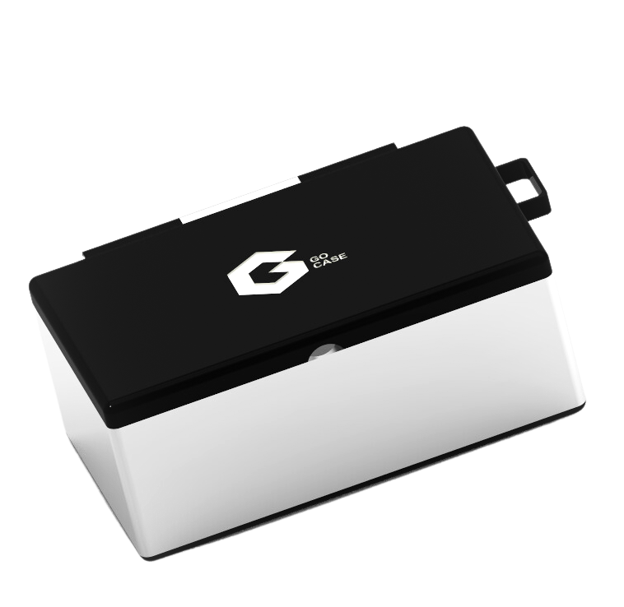

GO CASE

USER MANUEL

GUIDE



**GO CASE**

**TABLE OF CONTENTS**



A INTRODUCTION 04

PURPOSE OF THE MANUAL **05**

INTENDED USERS **05**

PRODUCT OVERVIEW **05**

SAFETY PRECAUTIONS **05**

B GETTING STARTED 06

UNPACKING AND INSPECTION **07**

ASSEMBLING THE TOILETRY CASE **07**

INITIAL SETUP **07**

STEPS TO ASSEMBLING THE GOCASE **08**

C

USING THE TOILETRY CASE 09

ORGANIZING YOUR TOILETRY CASE **10**

USING THE COMPARTMENTS **10**

PACKING AND STORING THE TOILETRY CASE **10**

CLEANING & MAINTENANCE **11**

TROUBLESHOOTING **11**

D

TRAVEL TIPS 12

PACKING TIPS **13**

TSA REGULATIONS **13**

TRAVELING WITH TOILETRIES **13**

INTERNATIONAL TRAVEL CONSIDERATIONS **13**

E

WARRANTY AND CUSTOMER SUPPORT 14

WARRANTY INFORMATION **15**

CONTACTING CUSTOMER SUPPORT **15**

RETURNS AND EXCHANGES **15**

F

APPENDIX 16

PRODUCT SPECIFICATIONS **17**

PRODUCT CARE AND SAFETY GUIDELINES **17**

GOCASE PARTS **18**

V1 TABLE OF CONTENTS 03

# A



## INTRODUCTION

### INTRODUCTION



**PURPOSE OF THE MANUAL**

THIS MANUAL’S MAIN GOAL IS TO GIVE YOU IN-DEPTH INFORMATION ON HOW TO USE AND MAINTAIN YOUR TOILETRY CASE. IT IS INTENDED TO ASSIST YOU IN COMPREHENDING THE FEATURES AND FUNCTIONALITIES OF THE PRODUCT AS WELL AS HOW TO PROPERLY MAINTAIN AND CLEAN YOUR GOCASE.

**INTENDED USERS**

ANYONE WHO HAS PURCHASED THE GOCASE IS THE TARGET AUDIENCE FOR THIS MANUAL. IT IS DESIGNED FOR CONSUMERS WHO WANT TO KNOW MORE ABOUT THE PRODUCT AND HOW TO USE IT EFFECTIVELY, BOTH NEW AND SEASONED SHOPPERS.

**PRODUCT OVERVIEW**

OUR TOILETRY CASE IS A USEFUL ACCESSORY DESIGNED TO MAKE CARRYING AND ORGANIZING YOUR PERSONAL CARE PRODUCTS EASIER. FOR KEEPING YOUR ESSENTIALS, LIKE TOOTHBRUSHES, TOOTHPASTE, SHAMPOOS, AND MORE, IT HAS A ROOMY MAIN AREA WITH NUMEROUS POCKETS AND COMPARTMENTS. YOUR TOILETRIES WILL ALWAYS BE DRY AND SECURE BECAUSE THEY ARE MANUFACTURED FROM STURDY, WATER-RESISTANT MATERIALS OF THE HIGHEST QUALITY.

**SAFETY PRECAUTIONS**

TO PROTECT YOUR SAFETY AND THE SAFETY OF OTHERS WHEN USING THIS PRODUCT, PLEASE READ AND ABIDE BY THE FOLLOWING SAFETY GUIDELINES:

**CAUTION**

1. **KEEP THE GOCASE OUT OF REACH OF CHILDREN AND PETS.**
2. **AVOID PLACING THE TOILETRY CASE IN DIRECT SUNLIGHT OR EXTREMELY HOT OR COLD ENVIRONMENTS.**
3. **TO CLEAN THE CASE, ONLY USE GENTLE CLEANSING PRODUCTS AND SOFT CLOTHS.**
4. **BEFORE TRAVELING WITH THE CASE, MAKE SURE IT IS ALWAYS SHUT SECURELY.**
5. INTRODUCTION 05

# B



## GETTING STARTED

### GETTING STARTED



UNPACKING AND INSPECTION

BEFORE USING YOUR TOILETRY CASE, CHECK FOR ANY DAMAGE OR FLAWS AFTER RECEIVING IT.

VERIFY THAT ALL HANDLES, COMPARTMENTS, AND ZIPPERS ARE IN GOOD FUNCTIONING ORDER.

IF YOU DISCOVER ANY PROBLEMS, GET IN CONTACT WITH OUR CUSTOMER SERVICE REPRESENTATIVES, AND OUR MANUFACTURERS WILL PROMPTLY PROVIDE A REPLACEMENT OR REPAIR.

ASSEMBLING THE TOILETRY CASE

SKIN, HAIR, AND DENTAL CARE GOODS SHOULD BE GROUPED WITH SIMILAR ITEMS WITHIN THE CASE.

TO KEEP YOUR TOILETRY KIT ORGANIZED AND MAKE IT SIMPLE TO FIND CERTAIN TIMES, USE OUR PROVIDED PACKING CUBES OR ORGANIZERS.

FOR EASY ACCESS, PLACE FREQUENTLY USED PRODUCTS LIKE TOOTHBRUSHES AND TOOTHPASTE NEAR THE TOP OF YOUR GOCASE.

INITIAL SETUP

PREPARE YOUR TOILETRY CASE WITH ALL THE SUPPLIES YOU INTEND TO CARRY BEFORE YOUR VACATION OR TRAVEL.

FOR SAFETY PURPOSES, PACK A COMPACT FIRST AID KIT CONTAINING COMMON MEDICAL ITEMS LIKE BANDAGES, PAINKILLERS, AND ANTISEPTIC WIPES.

YOU SHOULD PLACE ANY NECESSARY PRESCRIPTIONS OR MEDICATIONS IN A SEPARATE BAG OR IN THEIR ORIGINAL LABELED CONTAINERS.

TAKE THE TIME TO PROPERLY SET UP YOUR GOCASE; DOING SO ULTIMATELY IMPROVES YOUR TRAVEL EXPERIENCE.

1. GETTING STARTED 07

### GETTING STARTED

**CONT.**

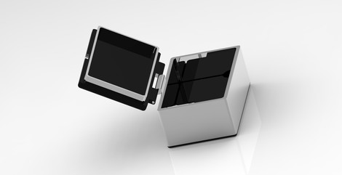

Steps To Assembling the GoCase

1

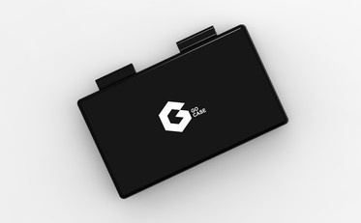

( Connecting Pin )

( Top Lid )

Locate the lid and the connecting pin

2

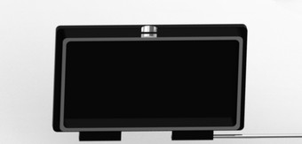

Slide the connecting pin through the opening of the hinges. It should go through both hinge insertion

3

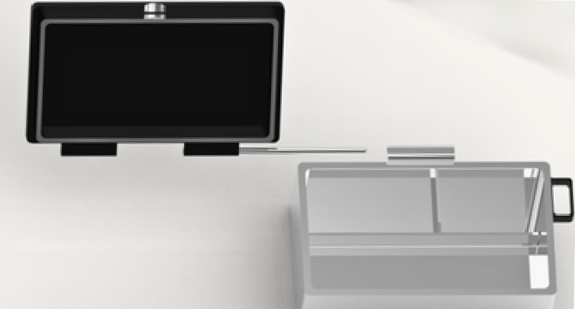

Slide the connecting pin with the top lid attached through the hinges of the base

4

Locate the mid-cover section and place it in the base after placing all your toiletries in

5

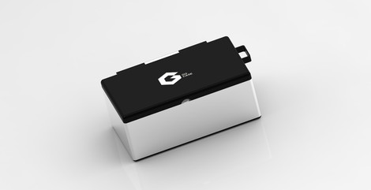

Add the last of toiletries on the top level of the GoCase & enjoy the easiness of traveling

B

GETTING STARTED

08

# C



## USING THE TOILETRY CASE

### USING THE TOILETRY CASE



ORGANIZING YOUR GOCASE

PREPARE YOUR GOCASE BY DECIDING ON THE TOILETRIES YOU’LL NEED FOR YOUR TRIP.

TO MAKE ACCESSING YOUR GOCASE DURING YOUR TRIP EASIER, YOU CAN EITHER HOOK IT ONTO YOUR CARRY-ON LUGGAGE OR KEEP IT IN A PROMINENT LOCATION IN YOUR LUGGAGE.

YOU SHOULD PLACE ANY NECESSARY PRESCRIPTIONS OR MEDICATIONS IN A SEPARATE BAG OR THEIR ORIGINAL, CLEARLY LABELED CONTAINERS.

GROUP SIMILAR ITEMS TOGETHER, SUCH AS SKIN, HAIR, AND DENTAL CARE PRODUCTS TOGETHER.

TO MAINTAIN ORDER AND MAKE IT SIMPLE TO LOCATE PRODUCTS IN YOUR GOCASE, ASSEMBLE THE DETACHABLE DIVIDERS ANY WAY YOU PLEASE TO FIT YOUR DESIRES.

USING THE COMPARTMENTS

TO ORGANIZE YOUR TOILETRIES, USE THE MANY COMPARTMENTS IN YOUR GOCASE TO ASSEMBLE YOUR ITEMS ACCORDINGLY.

TO AVOID INJURIES, KEEP CUTTING IMPLEMENTS LIKE RAZORS AND SCISSORS IN SEPARATE CONTAINERS.

TO MAKE YOUR GOCASE EASIER TO ACCESS WHEN USING THE BATHROOM, HANG IT FROM ANY BUILT-IN HOOKS OR HANGERS.

PACKING AND STORING THE GOCASE

WHEN NOT IN USE, KEEP YOUR TOILETRY CASE IN A COOL, DRY LOCATION TO PRESERVE IT AND INCREASE ITS LIFE.

TO PREVENT LOSS OR DAMAGE DURING TRANSIT, PACK YOUR GOCASE IN YOUR CARRY-ON BAG.

TO COMPLY WITH TSA GUIDELINES AND PREVENT FUTURE MISHAPS, BRING LIQUIDS AND GELS IN SEPARATE, CLEAR PLASTIC BAGS BEFORE TRAVELING.

1. USING THE TOILETRY CASE 10

### USING THE TOILETRY CASE CONT.



CLEANING & MAINTENANCE

IN ORDER TO AVOID THE GROWTH OF BACTERIA AND GERMS, CLEAN YOUR GOCASE ON A REGULAR BASIS USING WARM WATER AND MILD SOAP. EXCESS SOAP CAN AND WILL DAMAGE THE INTERIOR OF YOUR CASE.

TO AVOID MOLD AND MILDEW, LET YOUR GOCASE THOROUGHLY DRY BEFORE STORING IT. REGULARLY INSPECT HOOKS AND HANDLES FOR

DETERIORATION; REPLACE OR FIX THEM IF NECESSARY.

TROUBLESHOOTING

WHEN SPILLS OCCUR, WIPE THE AREA DOWN RIGHT AWAY WITH A DAMP TOWEL AND MILD SOAP.

IF THE CASE STILL FEELS STICKY FROM THE LIQUID, AFTER THE FIRST WIPE, APPLY AN EXTRA LAYER OF SOAP AND SCRUB GENTLY IN A CIRCULAR MOTION TO REMOVE THE STAIN.

###### V I S U A L G R A P H I C

**2**

**1 3**

***CAUTION***

**1 DO NOT**

**APPLY**

**2 EXCESSIVE AMOUNTS OF SOAP &**

**WATER**

1. USING THE TOILETRY CASE 11

# D



## TRAVEL TIPS

### TRAVEL TIPS



**PACKING TIPS**

TO MINIMIZE ROOM AND ADHERE TO TSA GUIDELINES, PACK YOUR TOILETRIES IN TRAVEL-SIZE CONTAINERS

THINGS SHOULD BE PACKED IN PRIORITY ORDER, WITH FREQUENTLY USED ITEMS AT THE TOP. TO KEEP YOUR TOILETRY KIT ORGANIZED AND MAKE IT EASIER TO FIND ITEMS, USE THE DIVIDERS PROVIDED. TO PREVENT SPILLAGE AND CONTAMINATION, MAKE SURE EACH TRAVEL-SIZE CONTAINER IS SEALED COMPLETELY BEFORE PACKING IT IN THE TOILETRY CASE.

**TSA REGULATIONS**

LIQUIDS AND GELS MUST BE PACKED IN AT LEAST A QUART-SIZED CONTAINER MADE OF TRANSPARENT PLASTIC AND WEIGHT NO MORE THAN 3.4 OUNCES (100 MILLILITERS)

YOU MUST REMOVE THE BAG FROM YOUR CARRY-ON LUGGAGE AND PUT IT IN A CONTAINER FOR X-RAY INSPECTIONS.

RAZORS, SCISSORS, AND OTHER POINTED ITEMS MUST BE IN CHECKED LUGGAGE OR A LOCKABLE TOILETRY CASE.

FOR A COMPLETE LIST OF FORBIDDEN ITEMS AND RULES, VISIT THE TSA WEBSITE ASSOCIATED WITH YOUR AIRLINE.

**TRAVELING WITH TOILETRIES**

CONSIDER USING LEAK-PROOF TRAVEL BOTTLES FOR YOUR LIQUIDS AND GELS.

PACK A SMALL TOWEL OR WASHCLOTH FOR PERSONAL HYGIENE. PACK ANY MEDICATIONS YOU NEED IN THEIR ORIGINALLY LABELED CONTAINERS AND KEEP THEM IN YOUR CARRY-ON LUGGAGE.

**INTERNATIONAL TRAVEL CONSIDERATIONS**

CHECK THE LAWS OF THE NATION YOU ARE TRAVELING TO REGARDING THE IMPORTATION OF PRESCRIPTION DRUGS AND TOILETRIES.

CONSULT YOUR DOCTOR BEFORE TRAVELING IF SPECIFIC SHOTS OR HEALTH CERTIFICATES ARE NEEDED FOR THE DESTINATION COUNTRY. TO CHARGE ELECTRIC TOOTHBRUSHES, ELECTRIC SHAVERS, AND OTHER ELECTRONIC AMENITIES, THINK ABOUT BRINGING A UNIVERSAL POWER ADAPTOR.

1. TRAVEL TIPS 13

# E



## WARRANTY & CUSTOMER SERVICE

**WARRANTY & SERVICE CENTER**



WARRANTY INFORMATION

WE STAND BEHIND THE QUALITY OF OUR GOCASES AND OFFER A LIMITED WARRANTY AGAINST DEFECTS IN MATERIALS AND WORKMANSHIP. THIS WARRANTY PERIOD LASTS ONE YEAR FROM THE DATE OF PURCHASE. IF YOUR GOCASE FAILS DUE TO MANUFACTURING DEFECTS DURING YOUR WARRANTY PERIOD, WE WILL REPAIR OR REPLACE IT FREE OF CHARGE.

TO MAKE A WARRANTY CLAIM, PLEASE CONTACT OUR CUSTOMER SUPPORT TEAM

**CONTACTING CUSTOMER SUPPORT**

IF YOU HAVE ANY QUESTIONS OR CONCERNS ABOUT YOUR TOILETRY CASE, PLEASE DON’T HESITATE TO CONTACT OUR CUSTOMER SUPPORT TEAM.

YOU CAN REACH US BY EMAIL

Alex Meade (ameade12@uncc.edu) Katyria Cruz (kcruz10@uncc.edu)

Rachel Boswell-Bailey (wbosewel3@uncc.edu) Daniel Mba (dmba@uncc.edu)

OUR TEAM IS AVAILABLE MONDAY THROUGH FRIDAY, FROM 9:00 AM TO 5:00 PM EST.

**RETURNS AND EXCHANGES**

WE WANT YOU TO BE COMPLETELY SATISFIED WITH YOUR PURCHASE, BUT IF FOR ANY REASON YOU’RE NOT, WE OFFER A HASSLE-FREE RETURN AND EXCHANGE POLICY.

IF YOU WISH TO RETURN OR EXCHANGE YOUR TOILETRY CASE, PLEASE CONTACT OUR CUSTOMER SUPPORT TEAM WITHIN 30 DAYS OF PURCHASE.

WE’LL PROVIDE YOU WITH A RETURN SHIPPING LABEL AND ISSUE A REFUND OR EXCHANGE ONCE WE RECEIVE THE ITEM BACK IN ITS ORIGINAL CONDITION.

**T E R M S O F S E R V I C E**

1. WARRANTY & CUSTOMER SERVICE 15

# F



## APPENDIX

### APPENDIX



##### PRODUCT SPECIFICATIONS

DIMENSIONS: BASE: 8.5 X 5 X 3

LID: 8.5 X 5 X 0.5

HINGES: 5.95 X 0.3 X 0.15

KEY CHAIN EXTENSION 1.45 X 0.75 X 0.4

PIN: 5.95 X 0.2

MATERIAL: PLASTIC COLOR: VARIES

CLOSURE: A CONNECTING PIN HANGING HOOK: YES

##### PRODUCT CARE AND SAFETY GUIDELINES

TO CLEAN THE GOCASE, WIPE IT DOWN WITH A DAMP CLOTH AND MILD SOAP. DO NOT MACHINE WASH OR DRY.

AVOID EXPOSING THE GOCASE TO EXTREME HEAT OR COLD, AS THIS CAN DAMAGE THE MATERIAL AND AFFECT ITS WATER-RESISTANT PROPERTIES.

WHEN NOT IN USE, STORE THE CASE IN A COOL, DRY PLACE AWAY FROM DIRECT SUNLIGHT.

DO NOT OVERPACK THE CASE, AS THIS CAN CAUSE THE SEAMS TO TEAR OR THE ZIPPER TO BREAK. KEEP THE CASE OUT OF REACH OF CHILDREN AND PETS TO PREVENT CHOKING HAZARDS OR ACCIDENTAL INGESTION OF SMALL PARTS.

1. APPENDIX 17

### GOCASE PARTS

###### EXTERIOR CASE/BASE

#### IIIIIII

**8.5 x 5 x 3**

**1**

**2**

**OUTSIDE LID**

#### IIIIIIIIIIIIIIII

**8.5 x 5 x 0.5**

**CONNECTING PIN**

#### IIIIIIIIIIII

**3**

**5.95 x 0.2 (d)**

**MIDSECTION COVER**

#### IIIII

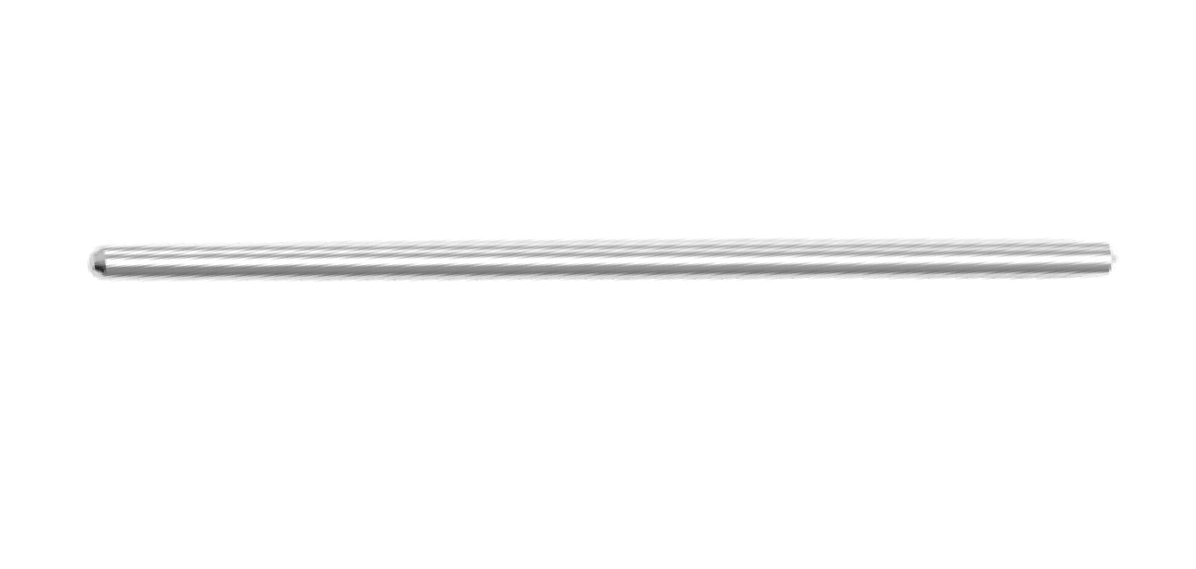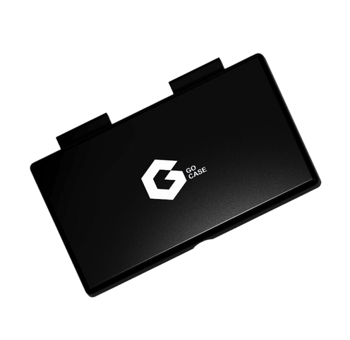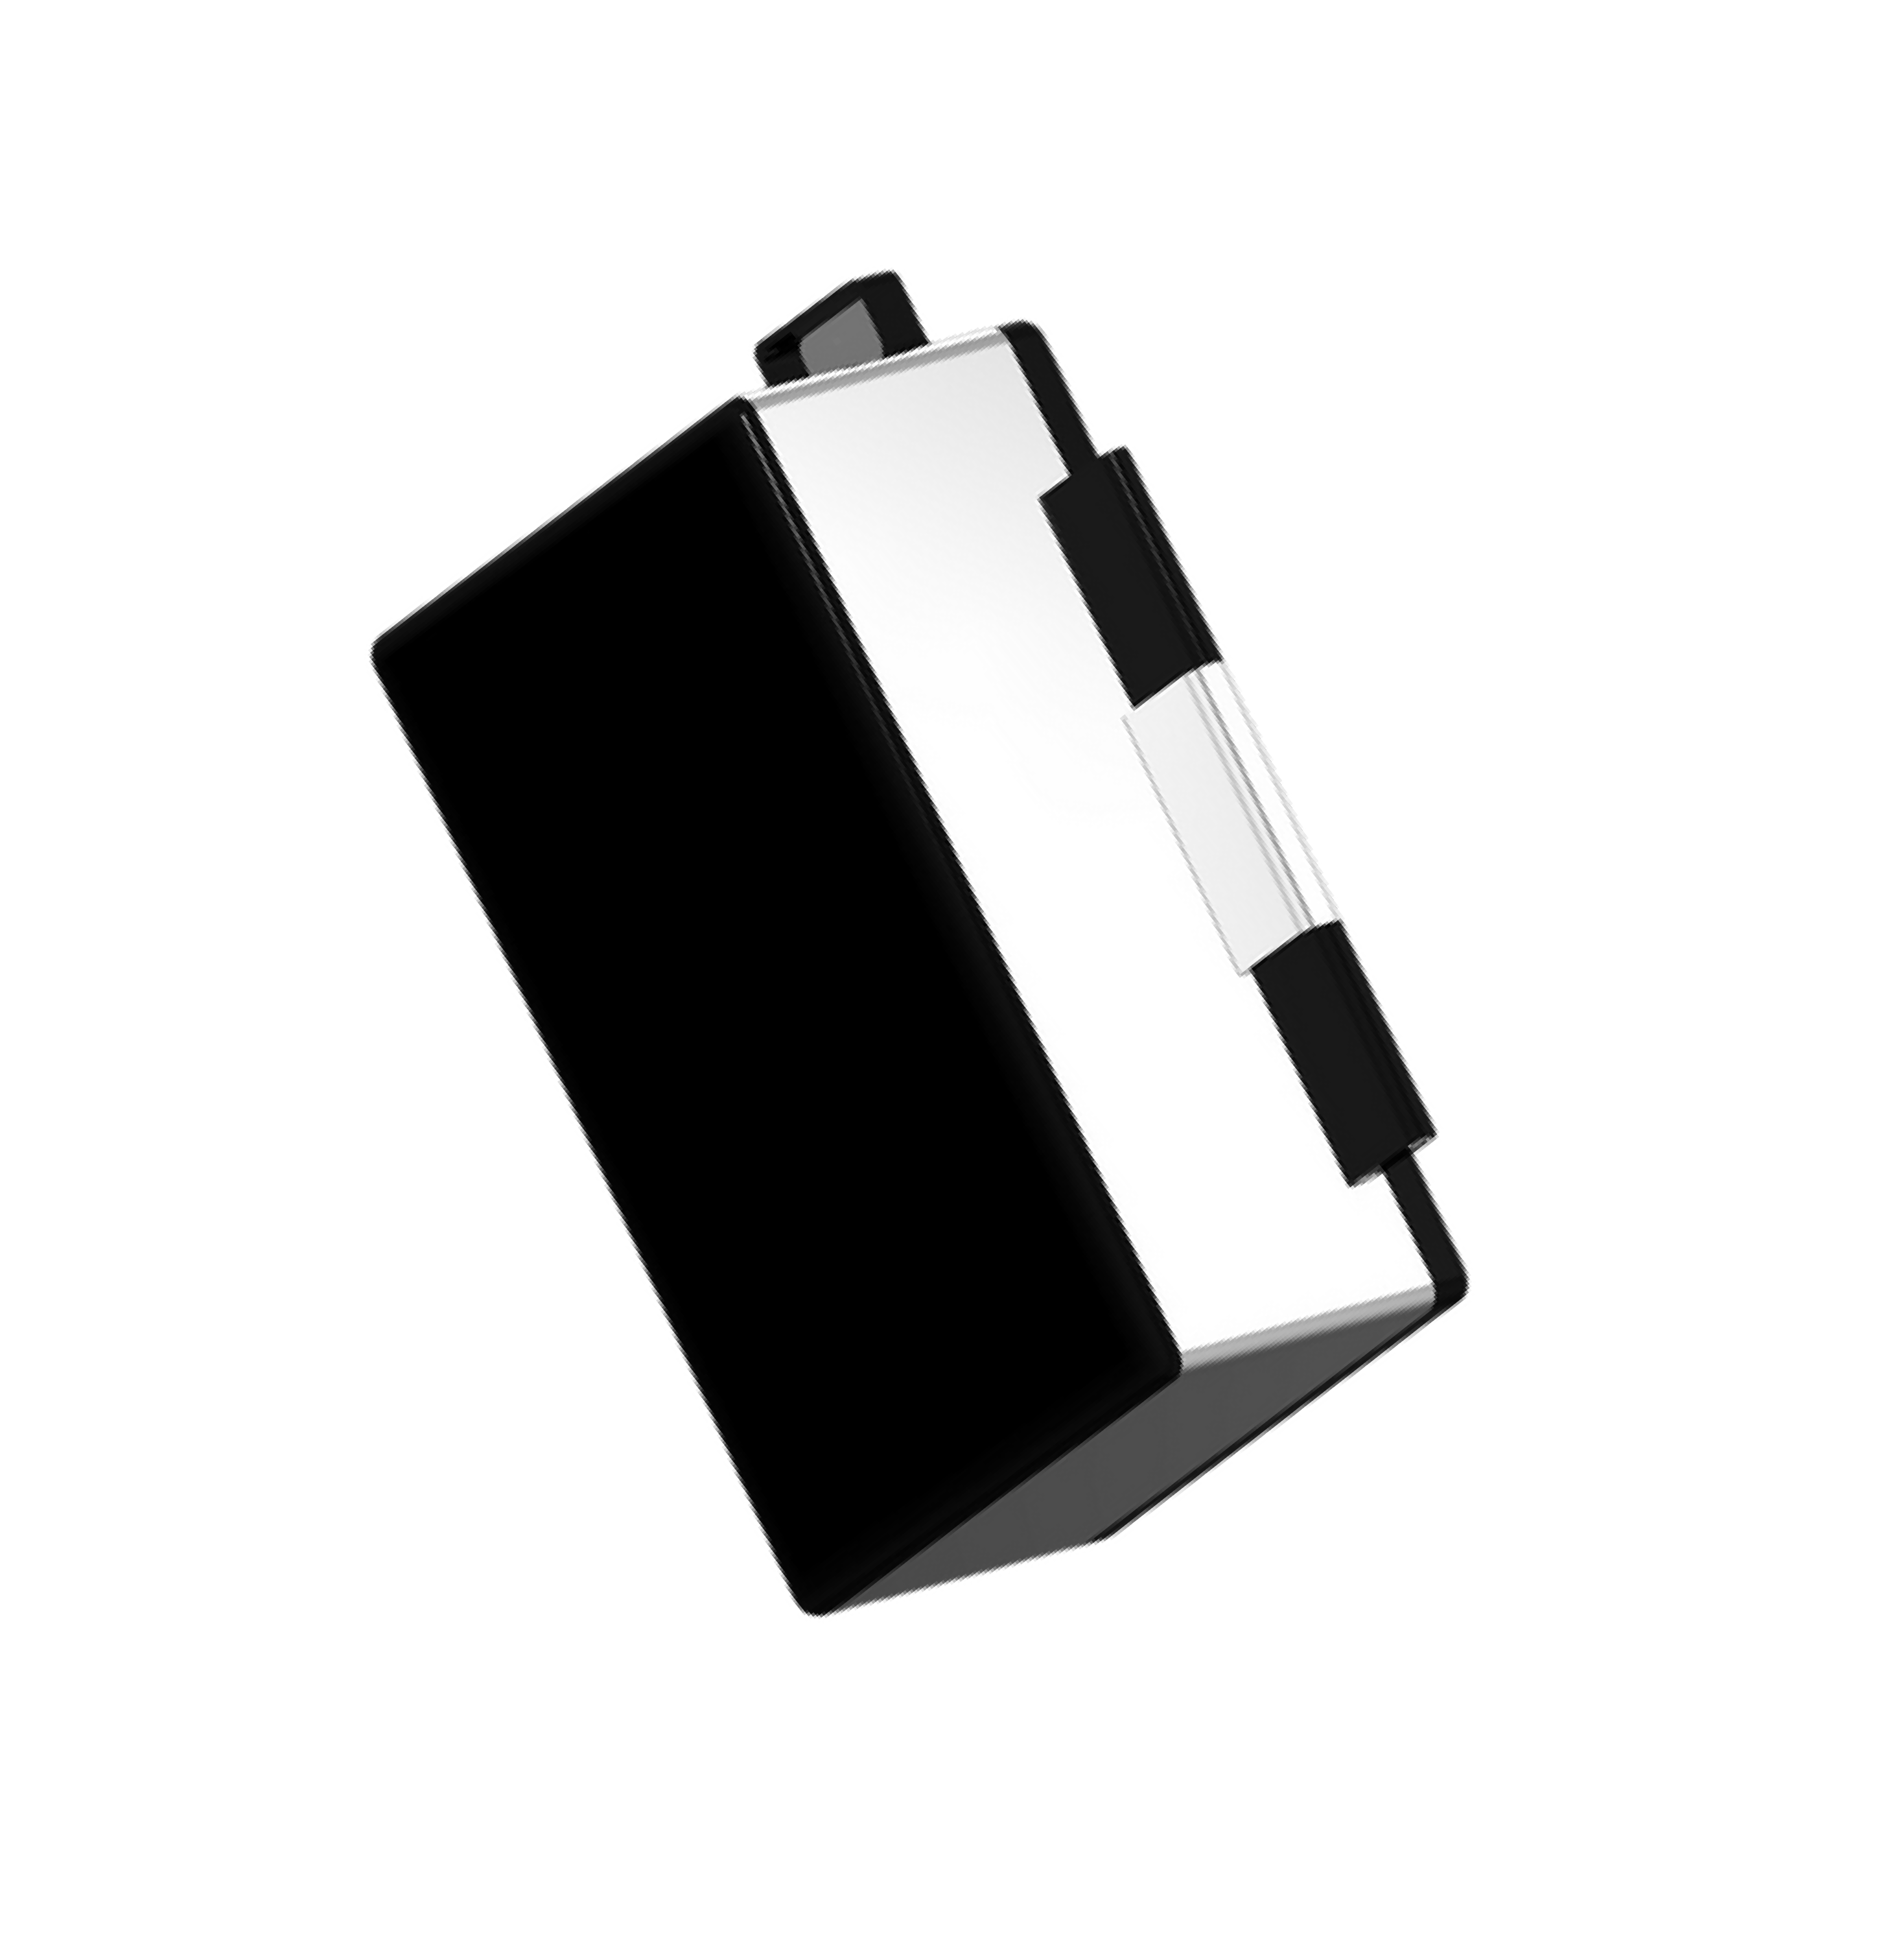

**8 x 4.5 x 0.1 (4.6 x 1.35 cut out)**

**4**

EXTRA GOCASE PARTS 18



**GO CASE**